Problem 9.11

We can express the equations as an augmented matrix.



**Forward Elimination**: Pivot by switching the rows 1 and 3:



Multiply row 1 by 3/8 = 0.375 and subtract from row2 to eliminate a21.

Multiply row1 by 2/-8 = -0.25 and subtract from row3 to eliminate a31.



Pivot again: Switch rows 2 and 3.



Multiply row 2 by 1.375/5.75 = 0.23913 and subtract from row3 to eliminate a32.



**Back Substitution**:

x3 = -16.22/8.109 = -2

x2 = (-43-(-1.5)(-2)) / -5.75 = 8

x1 = (-20 + 2(-2)-1(8)) / -8 = 4

b) Check the results:

2(4) – 6(8) – (-2) = -38

-3(4) – 8 + 7(-2) = -34

-8(4) + 8 – 2(-2) = -20

I obtained the same result using a Python program as well:-

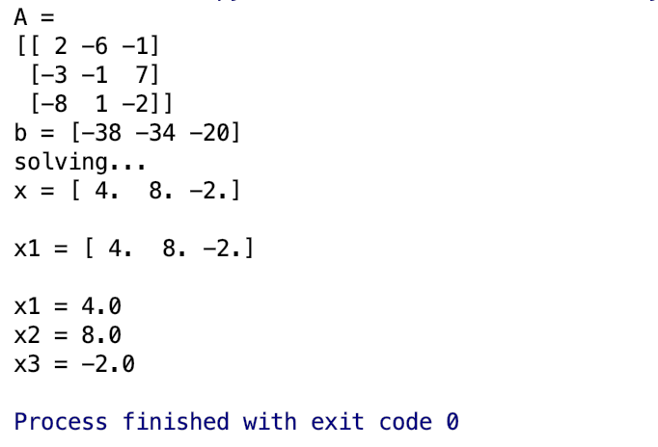

Problem 9.14

Free body diagrams of each of the parachutists have been provided. Summing the forces in the vertical direction and using Newton’s law gives a set of five simultaneous linear equations:

m1g – T12 – c1v = m1a

m2g + T12 – T23 – c2v = m2a

m3g + T23 – T34 – c3v = m3a

m4g + T34 – T45 – c4v = m4a

m5g + T45 – c1v = m5a

These equations have five unknowns: a, T12, T23, T34 and T45.

After substituting the known values, the equations can be expressed in the matrix form:

$\left[\begin{matrix}m1 & 1 & 0 & 0 & 0 \\ m2 & -1 & 1 & 0 & 0 \\ m3 & 0 & -1 & 1 & 0 \\ m4 & 0 & 0 & -1 & 1 \\ m5 & 0 & 0 & 0 & -1\end{matrix}\right]$ $\left[\begin{matrix}a \\ T12 \\ T23 \\ T34 \\ T45\end{matrix}\right]$ = $\left[\begin{matrix}449.55 \\ 627.75 \\ 453.6 \\ 591.75 \\ 792.9\end{matrix}\right]$

This system can be solved using Gauss elimination algorithm.

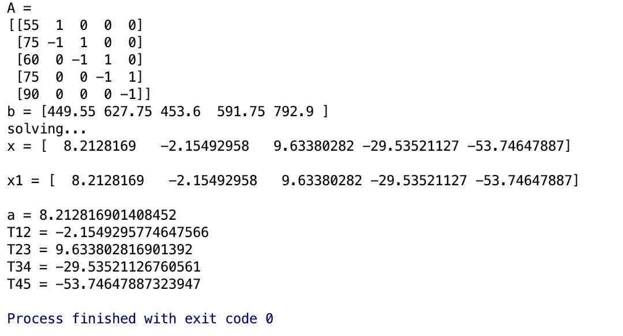

The results are as follows:-

a = 8.212 m/s2

T12 = -2.15 N

T23 = 9.63 N

T34 = -29.535 N

T45 = -53.746 N

Negative tensions indicate the parachutists were pushed together instead of being pulled apart.

By Gauss elimination method, we were able to solve 5 simultaneous equations and find the tension in each section of the cord.